Project Requirement:
I am currently working on a project where I am responsible for matching predefined keywords with the keywords in the 'Decoration' column of an Excel file, and based on these matches, assigning corresponding categories to the 'Categories' column of Excel. The file contains over 100,000 records. I am in the process of applying additional limitations, and I will continue making progress after discussing the requirements with my project manager (Eric). I am handling this project independently, and the final delivery is due by May 2025. At present, I am working on the object area part, and I will proceed with the next tasks once the documentation team provides further clarity on my questions.

Excel File Sheet:
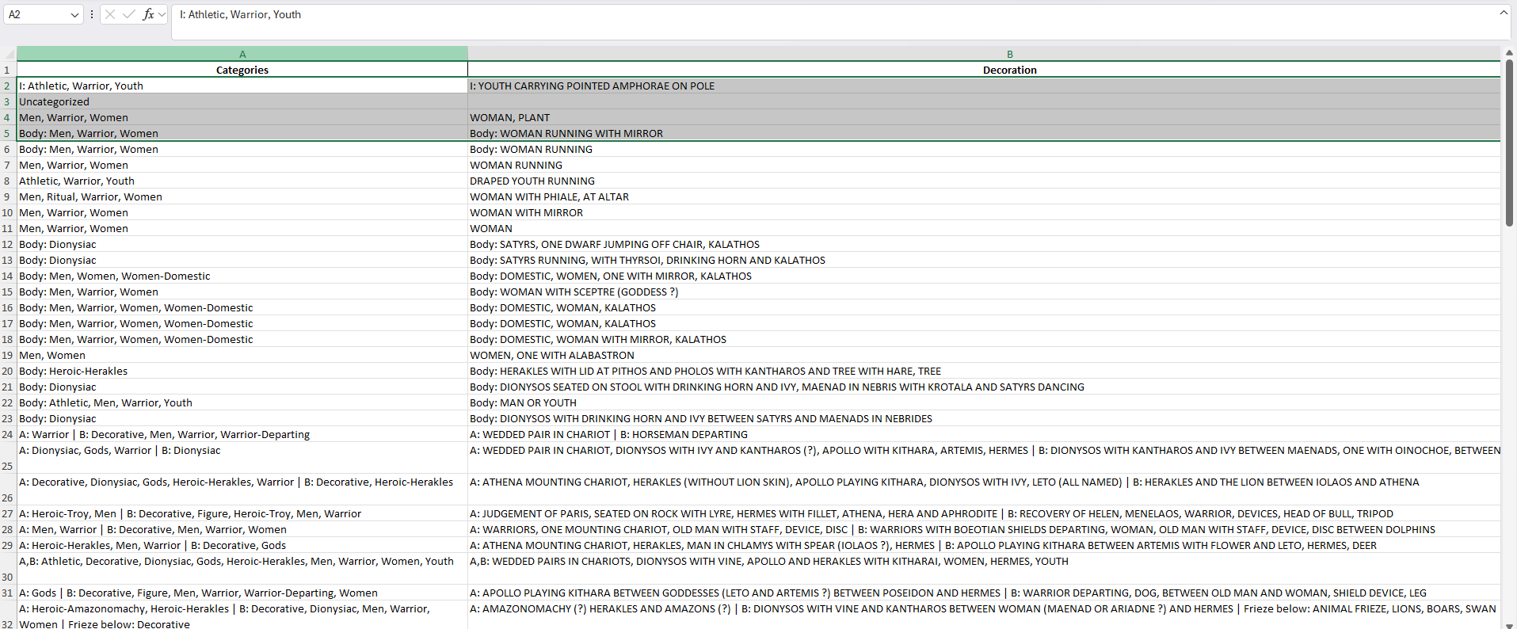

Code:
import pandas as pd
import re
# File path to the Excel file
file_path = 'Categories v2 - Edited.xlsx'
# Load the Excel file
try:
df = pd.read_excel(file_path, sheet_name='Sheet1')
except FileNotFoundError:
print("Error: File not found.")
exit()
# Predefined categories and keywords
categories_keywords = {
'Athletic': ['athlete', 'athletes', 'trainer', 'athletic', 'race', 'racing', 'horserace', 'chariot race', 'nude man', 'javelin', 'diskos', 'strigil', 'youth'],
'Warrior': ['warrior', 'warriors', 'horseman', 'horsemen', 'warship', 'warships', 'chariot', 'chariots', 'man', 'helmet', 'spear', 'sword', 'shield', 'arming', 'youth', 'rider'],
'Warrior-Departing': ['warrior departing', 'warrior leaving', 'warrior exiting', 'warriors departing', 'warriors exiting', 'warriors leaving', 'chariot departing', 'chariot leaving', 'chariot exiting', 'chariots departing', 'chariots leaving', 'horseman departing', 'horseman leaving', 'horseman exiting', 'horsemen departing', 'horsemen leaving', 'horsemen exiting'],
'Symposion': ['symposion'],
'Komos': ['komos'],
'Youth': ['youth', 'youths'],
'Men': ['man', 'men', 'hunt', 'rider', 'man youth', 'man youths', 'men youth', 'men youths'],
'Women-Domestic': ['domestic', 'woman chair column', 'women chair column'],
'Women': ['woman', 'women'],
'Group': ['group', 'figures', 'figure man', 'figure woman', 'figure youth', 'man woman', 'youth woman', 'men women', 'women youths'],
'Group-Wedding': ['wedding', 'bride groom', 'bride procession', 'groom procession'],
'Group-Erotic': ['erotic', 'courtship'],
'Figure': ['figure', 'arm', 'leg', 'torso', 'head'],
'Music': ['performance', 'instrument', 'instruments', 'kithara judges', 'kithara wreath', 'lyre judges', 'lyre wreath', 'pipes judges', 'pipes wreath'],
'Ritual': ['altar', 'shrine', 'nasikos', 'offering stele', 'phiale oinochoe woman', 'cult procession', 'stele offerings'],
'Dionysiac': ['dionysos', 'satyr', 'satyrs', 'maenad', 'maenads', 'silen', 'thrysos', 'tymbales'],
'Pursuit': ['pursuit', 'chase'],
'Heroic': [],
'Heroic-Fight': ['fight', 'battle', 'combat', 'duel', 'warriors fighting', 'warrior fighting'],
'Heroic-Amazonomachy': ['amazon fight', 'amazon battle', 'amazon combat', 'amazon duel', 'amazons fight', 'amazons combat', 'amazons battle', 'amazons fighting', 'amazonomachy'],
'Heroic-Centauromachy': ['centaur fight', 'centaur battle', 'centaur combat', 'centaur duel', 'centaurs battle', 'centaurs combat', 'centaurs fight', 'centaurs fighting', 'centauromachy'],
'Heroic-Herakles': ['herakles', 'hercules', 'alcmene', 'iphicles', 'omphale', 'deianira', 'iolaus'],
'Heroic-Theseus': ['theseus', 'aegeus', 'aethra', 'phaedra'],
'Heroic-Troy': ['troy', 'achilles', 'odysseus', 'agamemnon', 'ajax', 'hector', 'paris', 'helen', 'menelaus', 'priam', 'hecuba', 'cassandra', 'neoptolemus', 'laocoon'],
'Myth': ['myth', 'anodos figure', 'anodos man', 'anodos woman', 'return of hephaistos'],
'Myth-Gigantomachy': ['gigantomachy', 'giant combat', 'giant battle', 'giant fight', 'giants battle', 'giants combat', 'giants fight', 'giants fighting'],
'Myth-Triptoleomos': ['triptoleomos demeter', 'triptoleomos fire', 'child hearth'],
'Myth-Athena': ['athena olive tree', 'athena anodos', 'athena birth'],
'Gods': ['athena apollo', 'athena artemis', 'athena aphrodite', 'athena ares', 'athena dionysos', 'athena zeus', 'apollo artemis', 'apollo ares', 'apollo dionysos', 'apollo zeus', 'artemis aphrodite', 'artemis dionysos', 'aphrodite ares', 'aphrodite dionysos', 'aphrodite zeus', 'ares dionysos', 'dionysos zeus', 'zeus poseidon', 'zeus demeter', 'apollo', 'artemis', 'aphrodite', 'ares', 'dionysos', 'zeus', 'poseidon', 'hades', 'demeter'],
'Funerary': ['funerary', 'funeral', 'mourning', 'grave', 'graves', 'tomb', 'naiskos'],
'Theatrical': ['theatrical', 'actor', 'actors'],
'Decorative': ['decorative', 'design', 'pattern', 'vine', 'vines', 'tendril', 'tendrils', 'bird', 'birds', 'owl', 'dog', 'dogs', 'horse', 'floral', 'lotus', 'palmette', 'palmettes', 'sphinx', 'sphinxes', 'bull', 'palm', 'palms', 'sprig', 'griffin', 'gryphon', 'lion', 'ram', 'cat', 'animal', 'gorgoneion', 'siren', 'swan', 'swans', 'panther', 'boar', 'goat', 'eyes', 'deer', 'eagle', 'eagles', 'dolphin', 'ships']
}
def clean_text(text):
"""Remove special characters and convert text to lowercase for better matching."""
return re.sub(r'[^\w\s]', '', text.lower()) if isinstance(text, str) else ''
def categorize_text(text):
"""Assign categories based on keyword matching."""
assigned_categories = set()
gods_count = 0
cleaned_text = clean_text(text) # Clean description text
for category, keywords in categories_keywords.items():
for keyword in keywords:
if keyword in cleaned_text:
if category == 'Gods':
gods_count += 1
else:
assigned_categories.add(category)
if gods_count >= 2: # If at least 2 gods are mentioned, categorize as 'Gods'
assigned_categories.add('Gods')
return ', '.join(sorted(assigned_categories)) if assigned_categories else 'Uncategorized'
def process_object_areas(description):
"""Extract categories for each object area in a description."""
output = []
# Split the description into sections using '|'
sections = re.split(r'\s*\|\s*', description)
for section in sections:
section = section.strip()
match = re.match(r'^([\w\s,]+:)\s*(.*)', section) # Match object areas like "On rim:", "A:"
if match:
object_area = match.group(1).strip()
section_text = match.group(2).strip()
categories = categorize_text(section_text) if section_text else 'Uncategorized'
output.append(f"{object_area} {categories}")
else:
categories = categorize_text(section)
output.append(categories)
return ' | '.join(output)
# Apply the categorization function to the 'Decoration' column
df['Categories'] = df['Decoration'].astype(str).apply(process_object_areas)
# Save updated results to Excel
df.to_excel(file_path, index=False)
print("File updated successfully with categorized decorations.")

